**Student Management Information System**

**Name of Students:**

Kunal Nalawade 2018130031

Vishal Salvi 2019230069

Shivam Pawar 2019230068

**Batch C**

**Subject:** Web Technology

**Abstract:**

Student Information System provides a simple interface for maintenance of student information. It can be used by educational institutes or colleges to maintain the records of students easily. The creation and management of accurate, up-to-date information regarding a student’s academic career is critically important in the university as well as colleges.

Student information system deals with all kind of student details, academic related reports, college details, course details, curriculum, batch details and other resource related details too. It tracks all the details of a student from the day one to the end of the course which can be used for all reporting purpose, tracking of attendance, progress in the course, completed semesters, years, coming semester year curriculum details, exam details, project or any other assignment details, final exam result and all these will be available through a secure, online interface embedded in the college’s website.

**Features:**

**• Admission Details**- The system will hold the admission dates, the fees paid, overdues of students.

• **Attendance Record-** This will include attended lectures and labs, defaulter list of students

• **Examination section-** This will include examination schedules, results, list of students whom passed or failed.

Code:

Login.php

<?php

session_start();

if(isset($_POST['submit'])){

     $obj=new AppController();

     $_SESSION['login']=$_POST['id'];

     $obj->login($_POST['id'],$_POST['password']);

}

?>

<!DOCTYPE html>

<html lang="en">

<head>

    <meta charset="utf-8">

    <meta http-equiv="X-UA-Compatible" content="IE=edge">

    <meta name="viewport" content="width=device-width, initial-scale=1">

    <meta name="description" content="">

    <meta name="author" content="">

    <title>School Management Login </title>

    <!-- Bootstrap Core CSS -->

    <link href="../bower-components/bootstrap/dist/css/bootstrap.min.css" rel="stylesheet">

</head>

<body>

 <h2 align="center">Student Record Management System</h2>

    <div class="container">

        <br><br><br><br>

            <div class="col-md-4 col-md-offset-4">

                <div class="panel panel-primary">

                    <div class="panel-heading">

                     <h3 class="panel-title">Sign In</h3>

                    </div>

                    <div class="panel-body">

                        <form method="post">

                            <fieldset>

                                <div class="form-group">

             <input class="form-control" placeholder="Login Id"  id="id"name="id" type="text" autofocus autocomplete="off">

                                </div>

                                <div class="form-group">

                                    <input class="form-control" placeholder="Password" id="password"name="password" type="password" value="">

                                </div>

                                <!-- Change this to a button or input when using this as a form -->

                                <input type="submit" value="login" name="submit" class="btn btn-lg btn-success btn-block">

                            </fieldset>

                        </form>

                    </div>

                </div>

            </div>

        </div>

    </div>

    <!-- jQuery -->

    <script src="../bower_components/jquery/dist/jquery.min.js"></script>

    <!-- Bootstrap Core JavaScript -->

    <script src="../bower_components/bootstrap/dist/js/bootstrap.min.js"></script>

    <!-- Metis Menu Plugin JavaScript -->

    <script src="../bower_components/metisMenu/dist/metisMenu.min.js"></script>

    <script type="text/javascript">

            jQuery(function(){

                jQuery("#id").validate({

                    expression: "if (VAL.match(/^[a-z]$/)) return true; else return false;",

                    message: "Should be a valid id"

                });

                jQuery("#password").validate({

                    expression: "if (VAL.match(/^[a-z]$/)) return true; else return false;",

                    message: "Should be a valid password"

                });

            });

        </script>

</body>

</html>

Leftbar.php

<nav class="navbar navbar-default navbar-static-top" role="navigation"

            style="margin-bottom: 0">

            <div class="navbar-header">

                <button type="button" class="navbar-toggle" data-toggle="collapse"

                    data-target=".navbar-collapse">

                    <span class="sr-only">Toggle navigation</span> <span

                        class="icon-bar"></span> <span class="icon-bar"></span> <span

                        class="icon-bar"></span>

                </button>

                <a class="navbar-brand" href="index.html">Student Management System</a>

            </div>

                         <div class="navbar-default sidebar" role="navigation">

                <div class="sidebar-nav navbar-collapse">

                    <ul class="nav" id="side-menu">

                        <li>

                            <a href="#"><i class="fa fa-bar-chart-o fa-fw"></i> Course<span class="fa arrow"></span></a>

                            <ul class="nav nav-second-level">

                                <li>

                                    <a href="add-course.php">Add Course</a>

                                </li>

                                <li>

                                    <a href="view-course.php">View</a>

                                </li>

                            </ul>

                            </li>

                 <li>

                            <a href="#"><i class="fa fa-bar-chart-o fa-fw"></i>Subject<span class="fa arrow"></span></a>

                            <ul class="nav nav-second-level">

                                <li>

                                    <a href="add-subject.php">Add Subject</a>

                                </li>

                                <li>

                                    <a href="view-subject.php">View</a>

                                </li>

                            </ul>

                        </li>

                   <li>

                            <a href="register.php"><i class="fa fa-bar-chart-o fa-fw"></i>Register<span class="fa arrow"></span></a>

                  </li>

                   <li>

                         <a href="#"><i class="fa fa-bar-chart-o fa-fw"></i>View Students<span class="fa arrow"></span></a>

                            <ul class="nav nav-second-level">

                                <li>

                                    <a href="view.php">View Basic Info</a>

                                </li>

                                <li>

                                    <a href="view_personal.php">View Personal Info</a>

                                </li>

                                <li>

                                    <a href="view_contact.php">View Contact Info</a>

                                </li>

                            </ul>

                  </li>

                   <li>

                   <a href="#"><i class="fa fa-bar-chart-o fa-fw"></i>Attendance<span class="fa arrow"></span></a>

                            <ul class="nav nav-second-level">

                                <li>

                                    <a href="add_attendance.php">Add Attendance</a>

                                </li>

                                <li>

                                    <a href="attendance.php">View</a>

                                </li>

                            </ul>

                  </li>

                  <li>

                  <a href="#"><i class="fa fa-bar-chart-o fa-fw"></i>Examination<span class="fa arrow"></span></a>

                            <ul class="nav nav-second-level">

                                <li>

                                    <a href="add_examination.php">Add Marks</a>

                                </li>

                                <li>

                                    <a href="examination.php">View</a>

                                </li>

                            </ul>

                  </li>

                   <li>

                            <a href="logout.php"><i class="fa fa-bar-chart-o fa-fw"></i>Logout<span class="fa arrow"></span></a>

                  </li>

                  </ul>

                </div>

            </div>

        </nav>

Add-Course.php

<?php

session_start ();

if (! (isset ( $_SESSION ['login'] ))) {

    header ( 'location:../index.php' );

}

if(isset($_POST['submit'])){

    $obj=new AppController();

    $obj->create_course($_POST['course-short'],$_POST['course-full'],$_POST['cdate']);

}

?>

<!DOCTYPE html>

<html lang="en">

    <head>

        <meta charset="utf-8">

            <meta http-equiv="X-UA-Compatible" content="IE=edge">

                <meta name="viewport" content="width=device-width, initial-scale=1">

                    <meta name="description" content="">

                        <meta name="author" content="">

                            <title>add course</title>

                            <!-- Bootstrap Core CSS -->

                            <link href="../bower_components/bootstrap/dist/css/bootstrap.min.css"rel="stylesheet">

                                        </head>

                                        <body>

                                            <form method="post" >

                                                <div >

                                                    <!-- Navigation -->

                                                    <?php include('leftbar.php')?>;

                                                    <!--nav-->

                                                    <div id="page-wrapper">

                                                        <div class="row">

                                                            <div class="col-lg-12">

                                                                <h4 class="page-header">

                                                                    <?php echo strtoupper("welcome"." ".htmlentities($_SESSION['login']));?>

                                                                </h4>

                                                            </div>

                                                            <!-- /.col-lg-12 -->

                                                        </div>

                                                        <!-- /.row -->

                                                        <div class="row">

                                                            <div class="col-lg-12">

                                                                <div class="panel panel-default">

                                                                    <div class="panel-heading">Add Course</div>

                                                                    <div class="panel-body">

                                                                        <div class="row">

                                                                            <div class="col-lg-10">

                                                                                <div class="form-group">

                                                                                    <div class="col-lg-4">

                                                                                        <label>Course Short Name

                                                                                            <span id="" style="font-size:11px;color:red">*</span>

                                                                                        </label>

                                                                                    </div>

                                                                                    <div class="col-lg-6">

                                                                                        <input class="form-control" name="course-short" id="cshort" required="required" >

                                                                                            <!-- <span id="course-availability-status" style="font-size:12px;"></span></div> -->

                                                                                        </div>

                                                                                </div>

                                                                                        <br>

                                                                                            <br>

                                                                                                <div class="form-group">

                                                                                                    <div class="col-lg-4">

                                                                                                        <label>Course Full Name

                                                                                                            <span id="" style="font-size:11px;color:red">*</span>

                                                                                                        </label>

                                                                                                    </div>

                                                                                                    <div class="col-lg-6">

                                                                                                        <input class="form-control" name="course-full" id="cfull" required="required"  >

                                                                                                            <!-- <span id="course-status" style="font-size:12px;"></span>-->

                                                                                                        </div>

                                                                                                    </div>

                                                                                                    <br>

                                                                                                        <br>

                                                                                                            <div class="form-group">

                                                                                                                <div class="col-lg-4">

                                                                                                                    <label>Creation Date</label>

                                                                                                                </div>

                                                                                                                <div class="col-lg-6">

                                                                                                                    <input class="form-control" value="20-05-2020" readonly="readonly" name="cdate">

                                                                                                                    </div>

                                                                                                                </div>

                                                                                                            </div>

                                                                                                            <br>

                                                                                                                <br>

                                                                                                                    <div class="form-group">

                                                                                                                        <div class="col-lg-4"></div>

                                                                                                                        <div class="col-lg-6">

                                                                                                                            <br>

                                                                                                                                <br>

                                                                                                                                    <input type="submit" class="btn btn-primary" name="submit" value="Create Course">

                                                                                                                                    </button>

                                                                                                                                </div>

                                                                                                                            </div>

                                                                                                                        </div>

                                                                                                                    </div>

                                                                                                                </div>

                                                                                                            </div>

                                                                                                        </div>

                                                                                                    </div>

                                                                                                </div>

                                                                                            </div>

                                                                                        </div>

                                                                                        <script src="../bower_components/jquery/dist/jquery.min.js"type="text/javascript"></script>

                                                                                        <script src="../bower_components/bootstrap/dist/js/bootstrap.min.js"type="text/javascript"></script>

                                                                                    </form>

                                                                                </body>

                                                                            </html>

View-course.php

<?php

session_start ();

if (! (isset ( $_SESSION ['login'] ))) {

    header ( 'location:../index.php' );

}

    $obj=new AppController();

    $courses=$obj->showCourse();

?>

<!DOCTYPE html>

<html lang="en">

<head>

    <meta charset="utf-8">

    <meta http-equiv="X-UA-Compatible" content="IE=edge">

    <meta name="viewport" content="width=device-width, initial-scale=1">

    <meta name="description" content="">

    <meta name="author" content="">

    <title>view course</title>

    <link href="../bower_components/bootstrap/dist/css/bootstrap.min.css" rel="stylesheet">

    <link href="../bower_components/font-awesome/css/font-awesome.min.css" rel="stylesheet" type="text/css">

</head>

<body>

    <div >

        <!-- Navigation -->

     <?php include('leftbar.php')?>;

         <nav>

        <div id="page-wrapper">

            <div class="row">

                <div class="col-lg-12">

                   <h4 class="page-header"> <?php echo strtoupper("welcome"." ".htmlentities($_SESSION['login']));?></h4>

                </div>

                <!-- /.col-lg-12 -->

            </div>

            <!-- /.row -->

            <div class="row">

                <div class="col-lg-12">

                    <div class="panel panel-default">

                        <div class="panel-heading">

                            View Course

                        </div>

                        <!-- /.panel-heading -->

                        <div class="panel-body">

                            <div >

                                <table class="table table-striped table-bordered table-hover" >

                                    <thead>

                                        <tr>

                                            <th>S No</th>

                                            <th>Short Name</th>

                                            <th>Full Name</th>

                                            <th>Created Date</th>

                                        </tr>

                                    </thead>

                                    <tbody>

                                    <?php

                                         $sn=1;

                                     foreach($c as $courses){?>

                                        <tr >

                                            <td><?php echo $sn?></td>

                                            <td><?php echo htmlentities( strtoupper($c->cshort));?></td>

                                            <td><?php echo htmlentities(strtoupper($c->cfull));?></td>

                                            <td><?php echo htmlentities($c->cdate);?></td>

                                        </tr>

                                    <?php $sn++;}?>

                                    </tbody>

                                </table>

                            </div>

                        </div>

                        <!-- /.panel-body -->

                    </div>

                    <!-- /.panel -->

                </div>

                <!-- /.col-lg-12 -->

            </div>

            <!-- /.row -->

        </div>

        <!-- /#page-wrapper -->

    </div>

    <!-- /#wrapper -->

    <!-- jQuery -->

    <script src="../bower_components/jquery/dist/jquery.min.js"></script>

    <!-- Bootstrap Core JavaScript -->

    <script src="../bower_components/bootstrap/dist/js/bootstrap.min.js"></script>

</html>

**Screenshot:**

**Login page:**

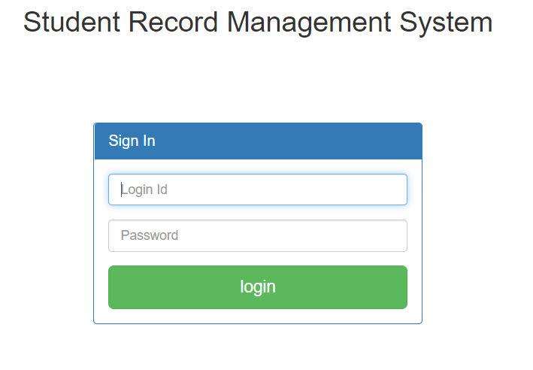

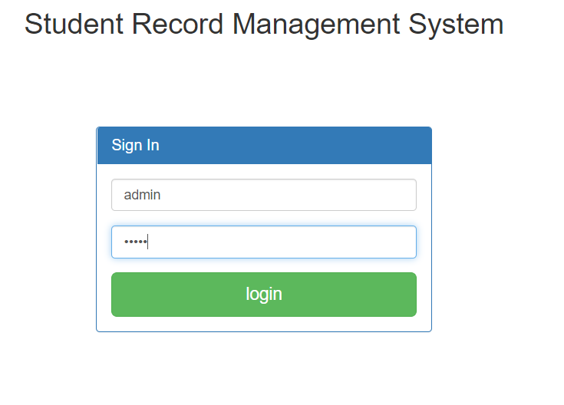

**Add Course:** Teacher add courses in curriculum.

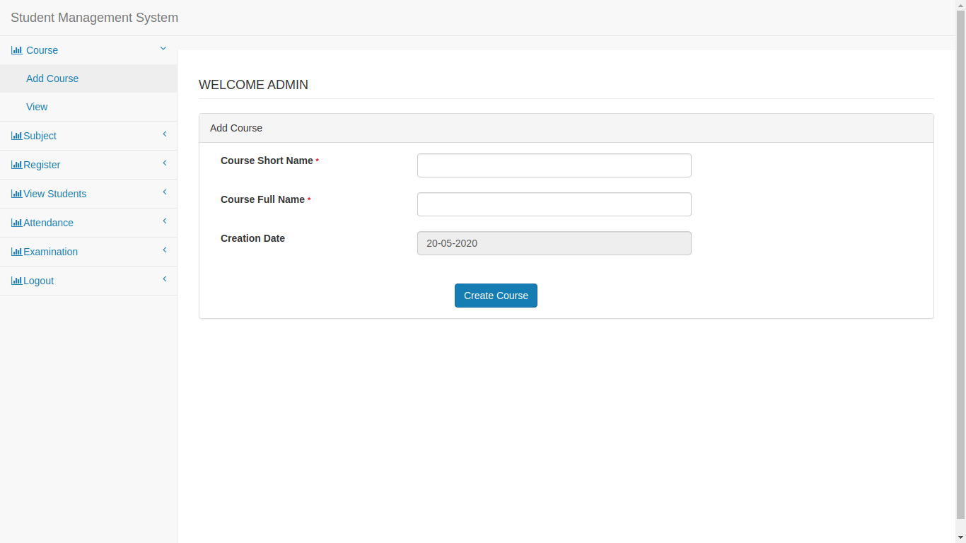

**View Course:**

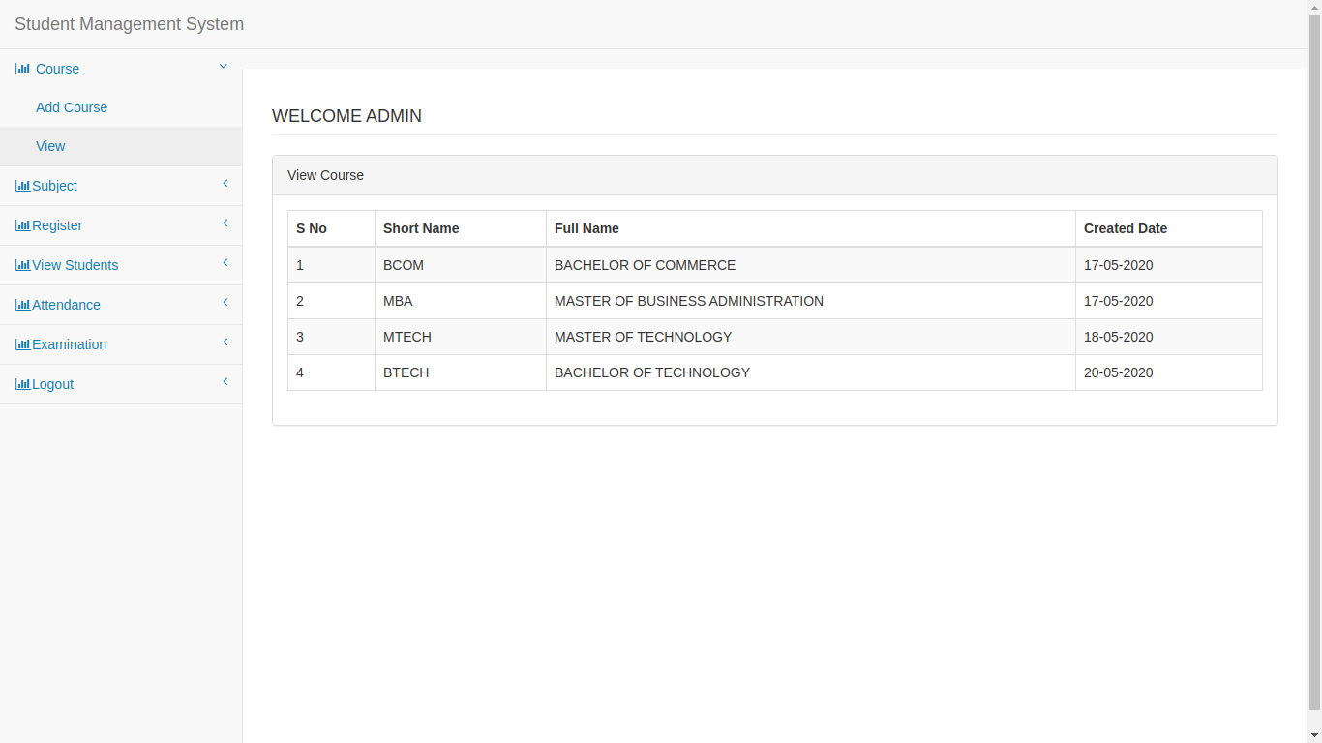

**Add Subject:** Teacher add subject depending upon course

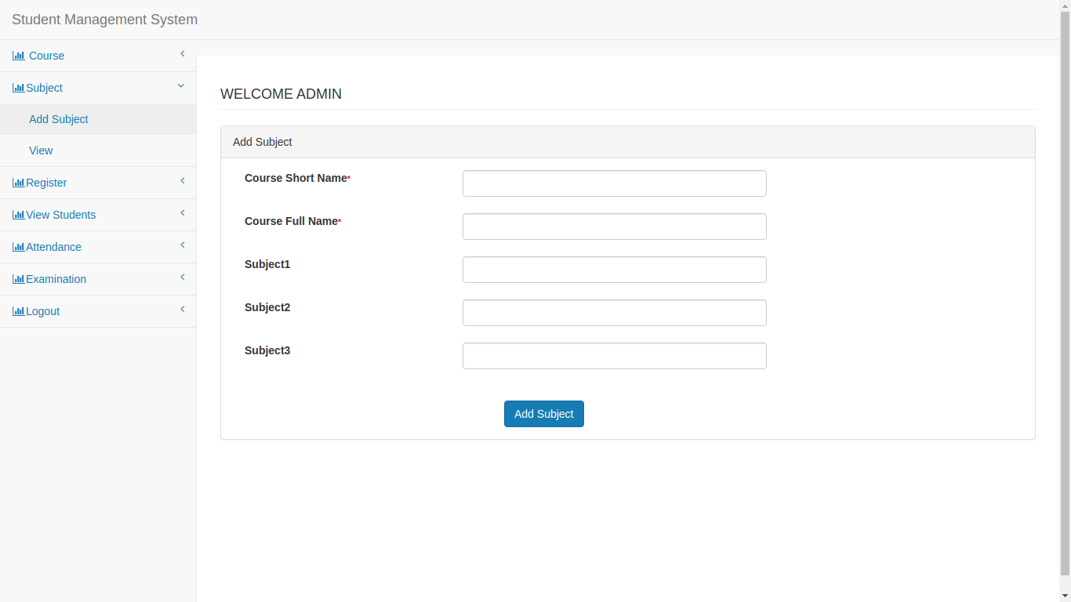

**View Subject:**

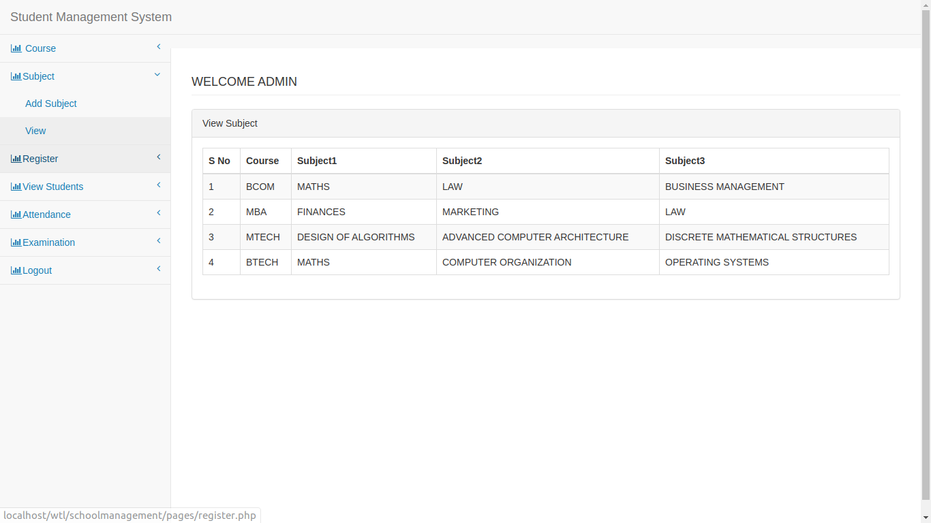

**Register:** Student Details

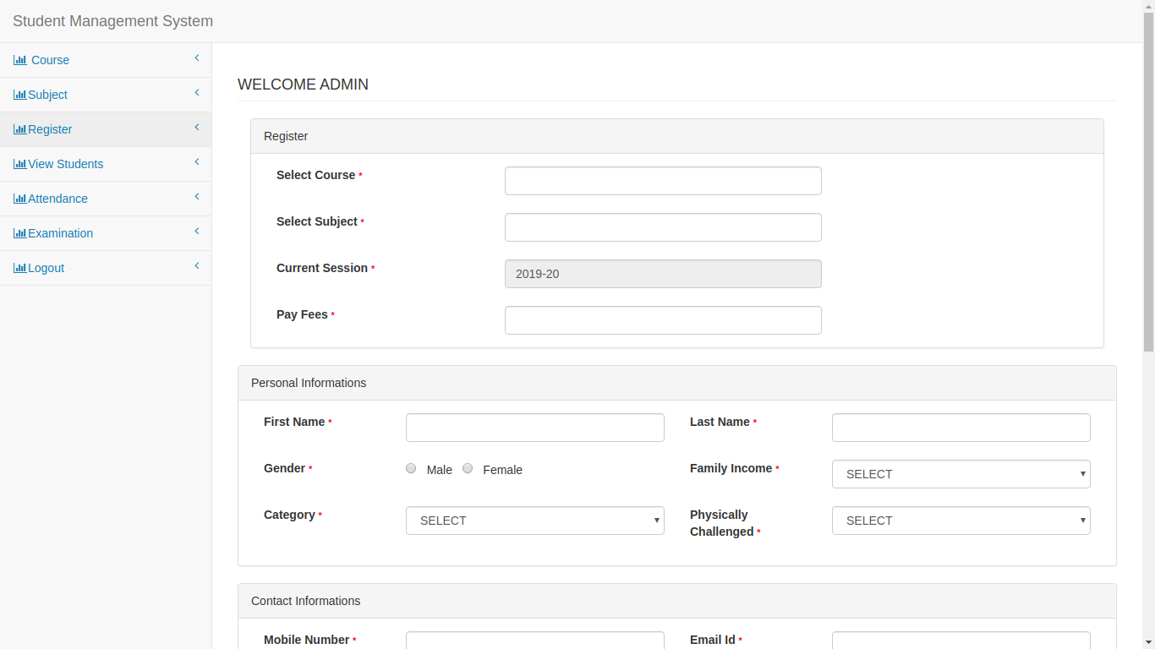

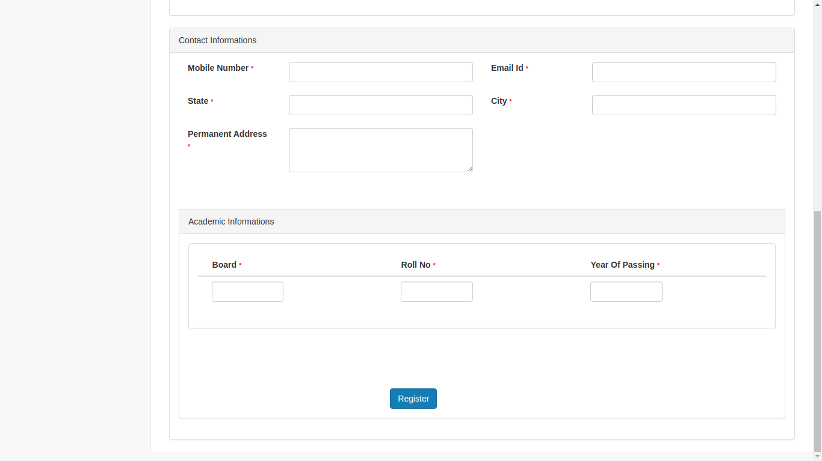

**Technologies & Tools we used:**

* Laravel Framework (PHP framework)
* phpMyAdmin (for database management)
* JavaScript and Ajax
* Bootstrap (for styling)
* Visual Studio Code and Git

**Conclusion:** Thus we implement login page , Add Courses , Add Subject and Student registration as well as view the details about courses and subjects.